**APPLICATION AND DATABASE ORCHESTRATION USING KUBERNETES**

**Project Scope:** Data orchestration provides the answer to making your data more useful and available. But ultimately, it goes beyond simple data management. In the end, orchestration is about using data to drive actions, to create real business value.

**Purpose:** To build application services that span multiple containers, schedule containers across a cluster, scale those containers, and manage their health over time.

**Tools Used:**

Minikube | Kubectl | Helm | Chocolatey | Prometheus | Grafana

**Technologies Used:**

Docker | Kubernetes

**Proof of concept:**

Go to the path of the file in the pc **C:\Users\ADMIN\Desktop\k8s\app\details** and connect to the git bash using the above path.

To login and connect to the docker desktop (local repository) we use the command:

**Docker login**

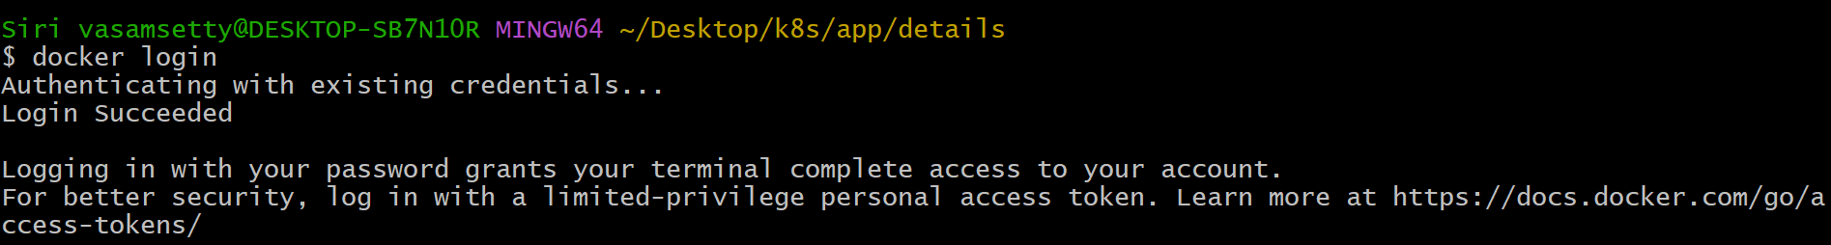

To build the image of the “details” we use the command: **docker build -t details .**

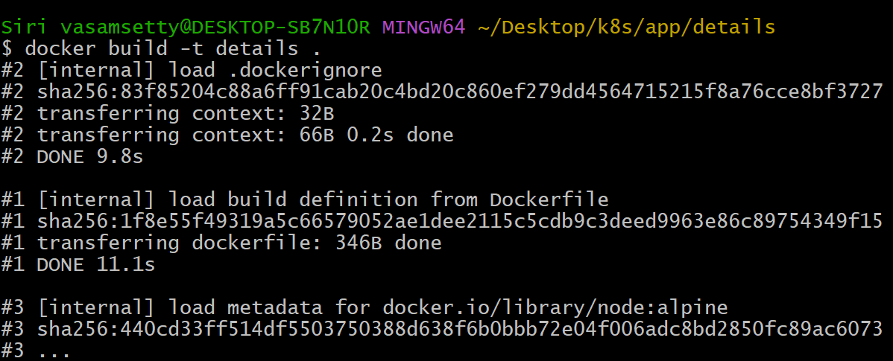

After building the image “details” image is reflected in the docker desktop

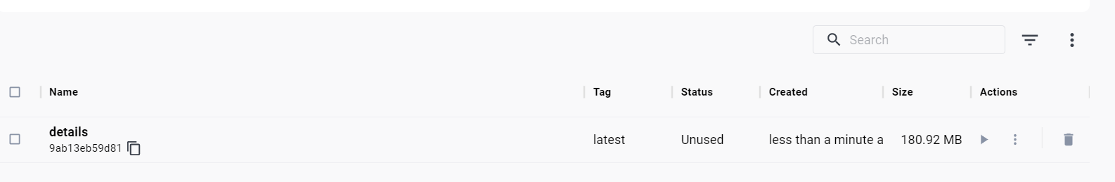

To create the repository in the docker we use the command: **docker tag details:latest siri0065/details**



To push the file into the created repository we use the command: **docker push siri0065/details**

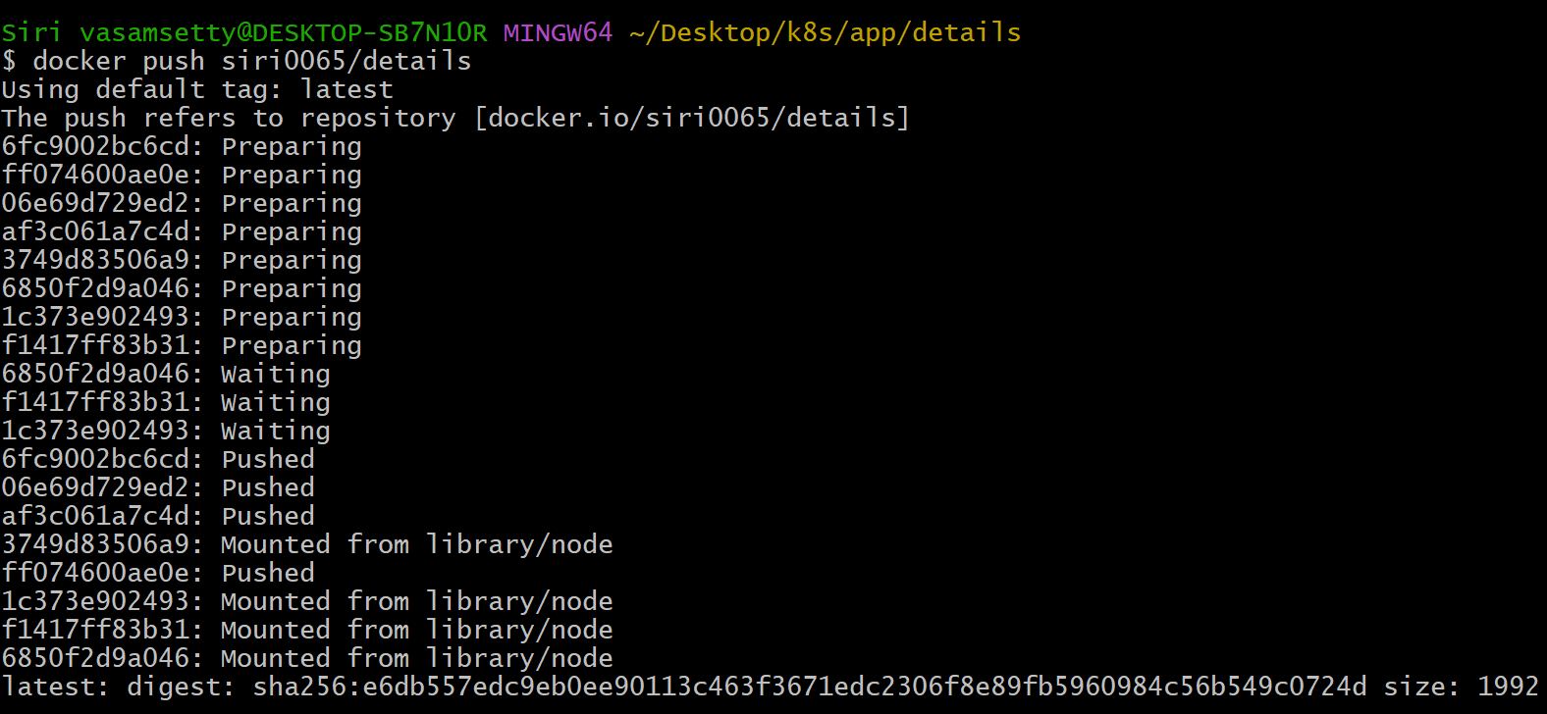

After pushing the application “details” to the is reflected in the docker desktop

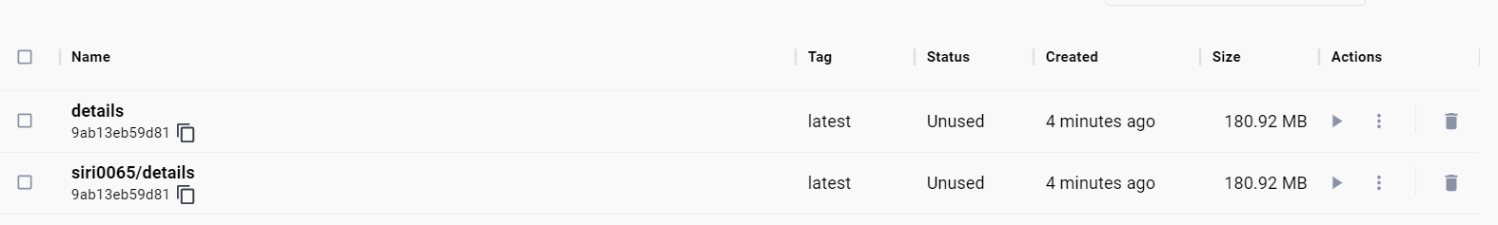

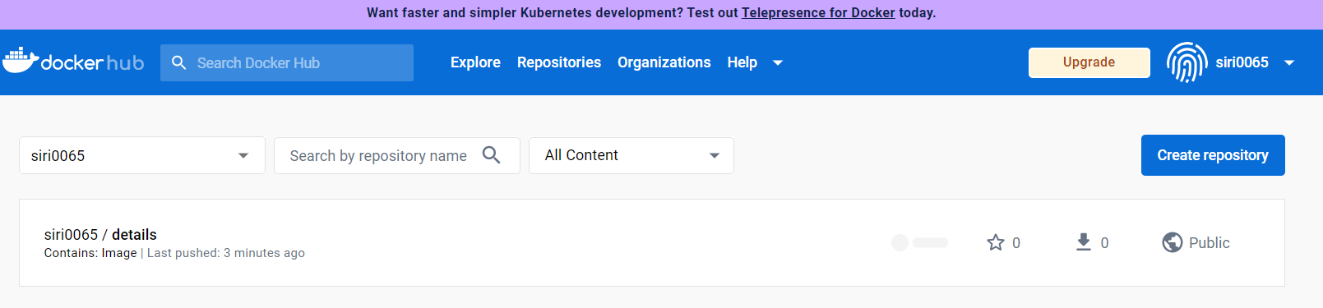

To connect to the docker we use the command: **Docker login**

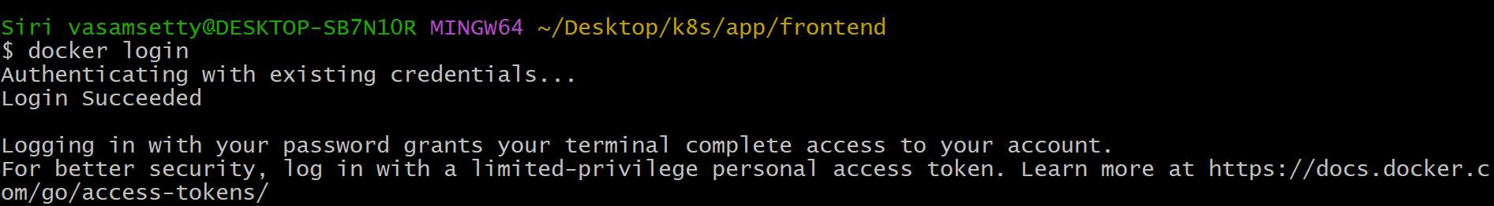

To build the image of the “frontend” we use the command: **docker build -t frontend .**

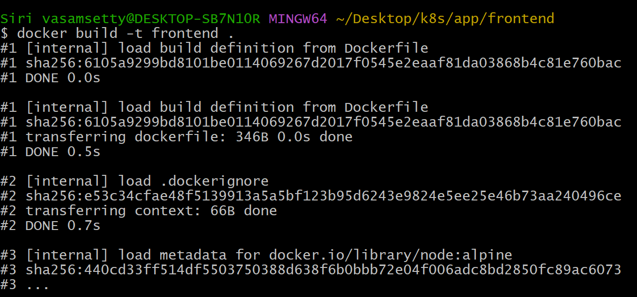

After building the image “frontend” image is reflected in the docker desktop

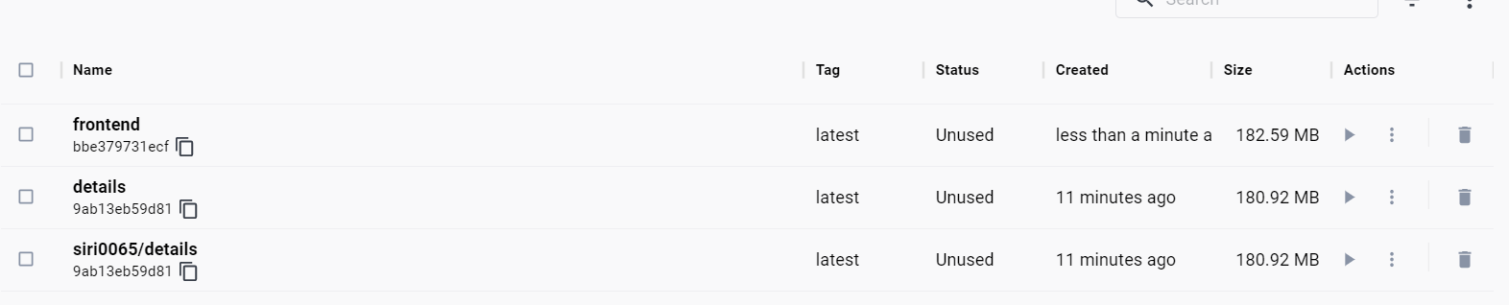

To create the repository in the docker we use the command: **docker tag details:latest siri0065/frontend**



To push the file into created repository we use the command: **docker push siri0065/frontend**

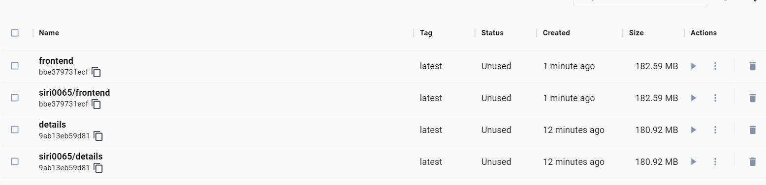

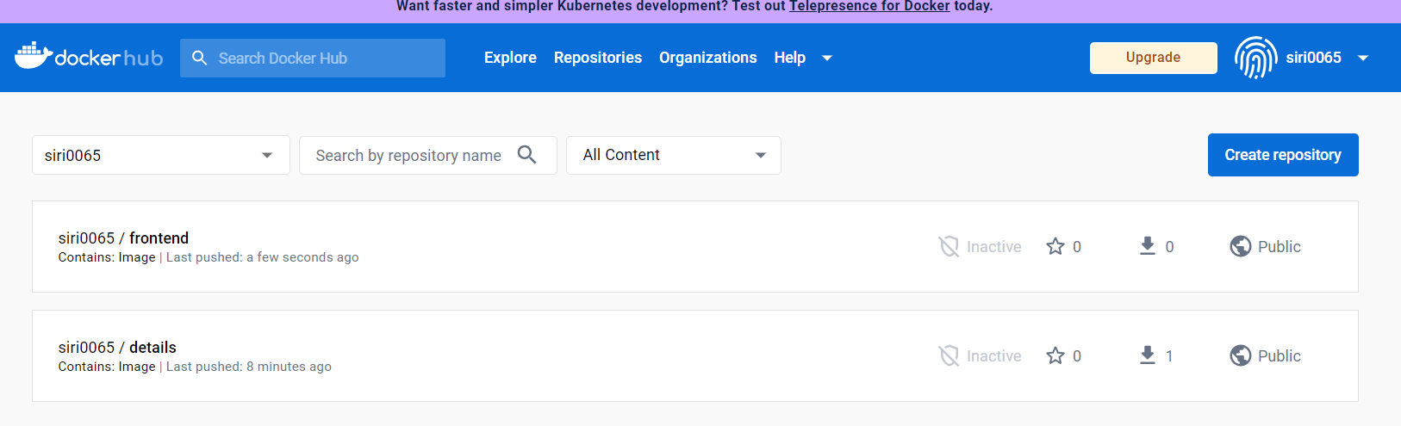

To login and connect to the docker desktop (local repository) we use the command: **Docker login**

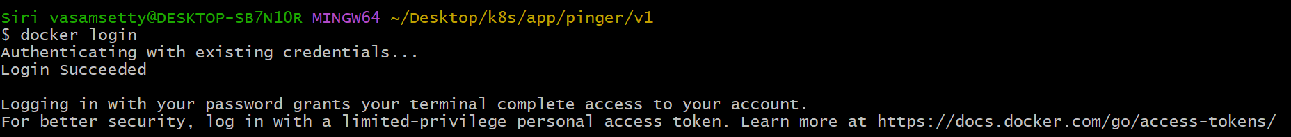

To build the image of the “pinger<<v1” we use the command: **docker build -t v1 .**

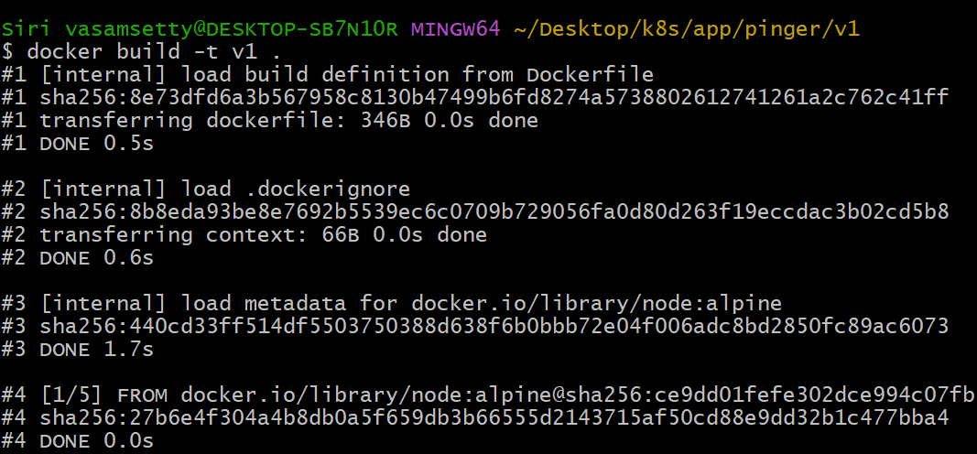

To create the repository in the docker we use the command: **docker tag details:latest siri0065/v1**



To push the file into created repository we use the command: **docker push siri0065/v1**

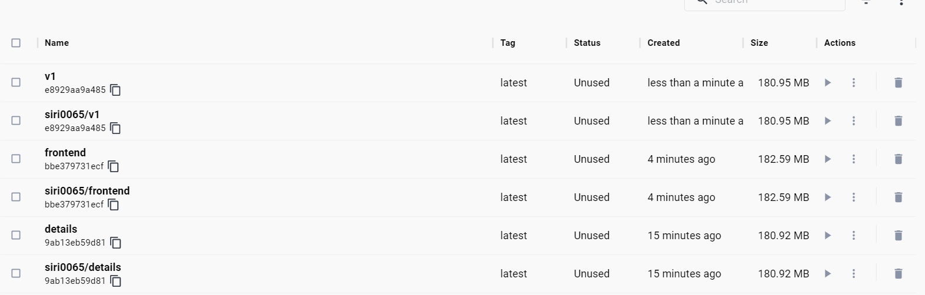

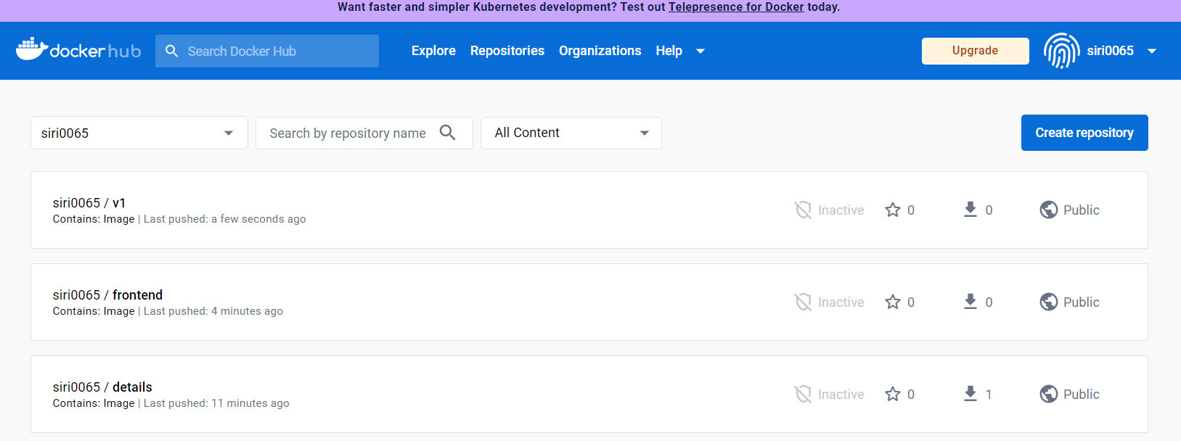

To connect to the docker we use the command: **Docker login**

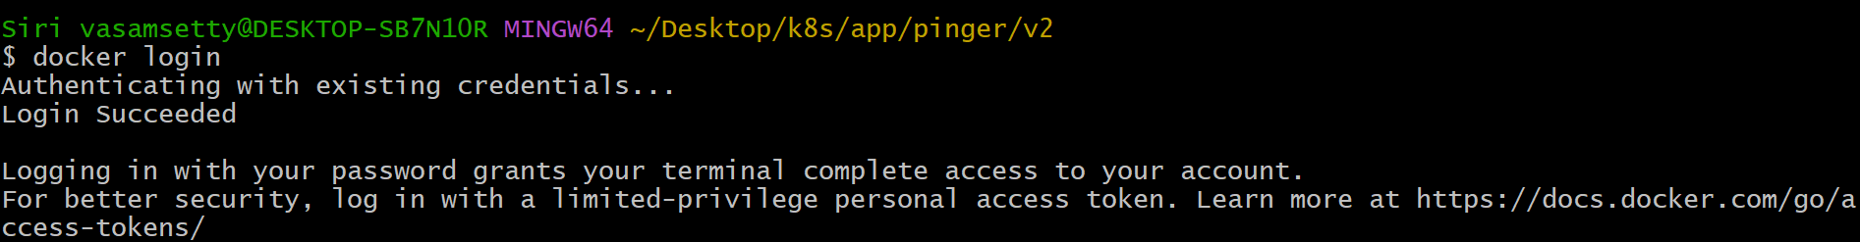

To build the image of the “frontend” we use the command: **docker build -t v2 .**

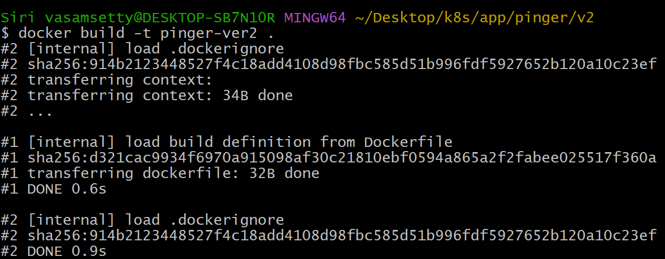

To create the repository in the docker we use the command: **docker tag details:latest siri0065/v2**



To push the file into created repository we use the command: **docker push siri0065/v2**

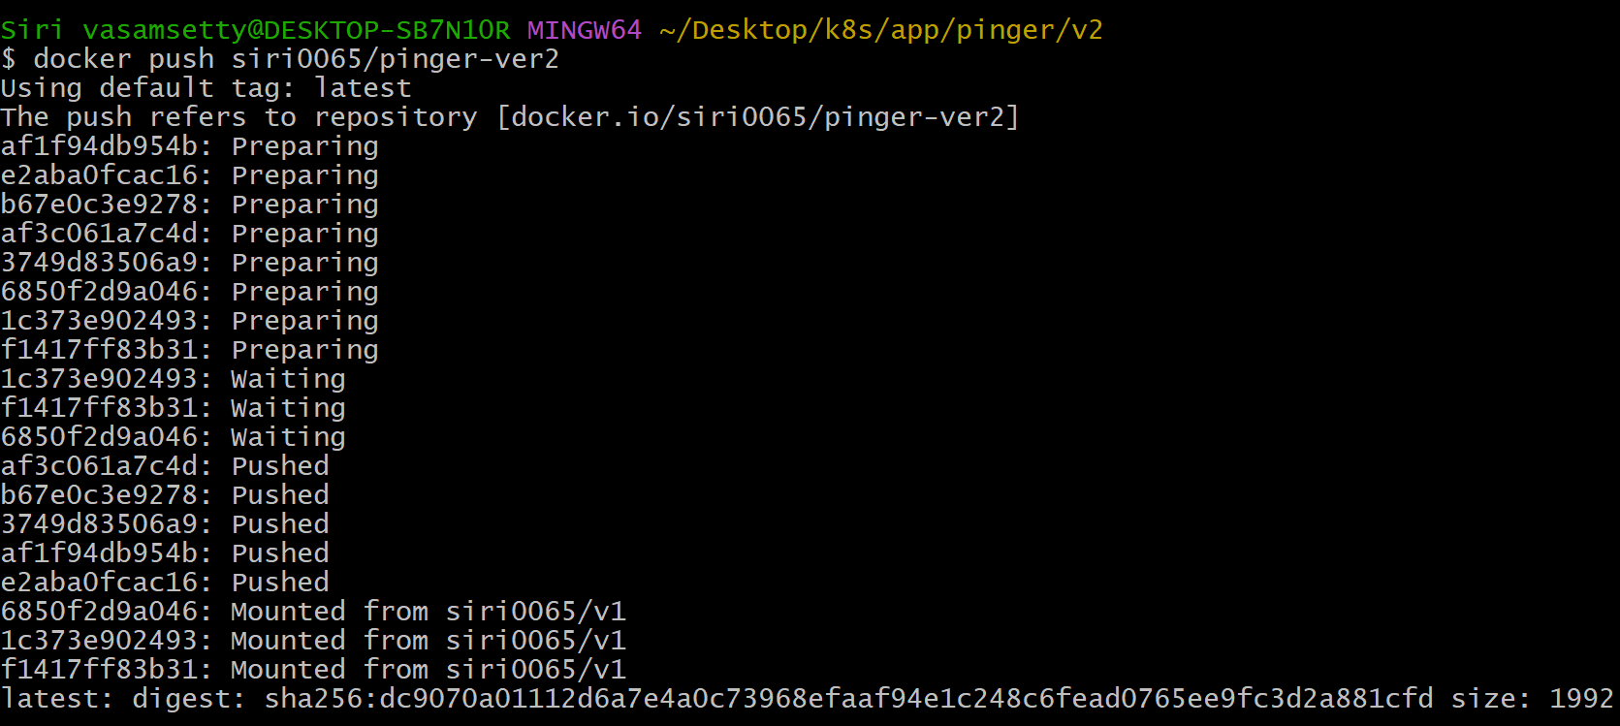

To push the file into created repository we use the command: **docker push siri0065/v2**

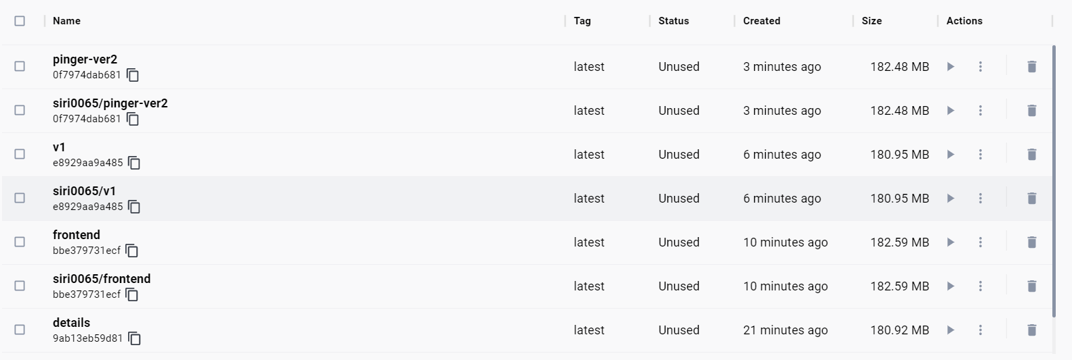

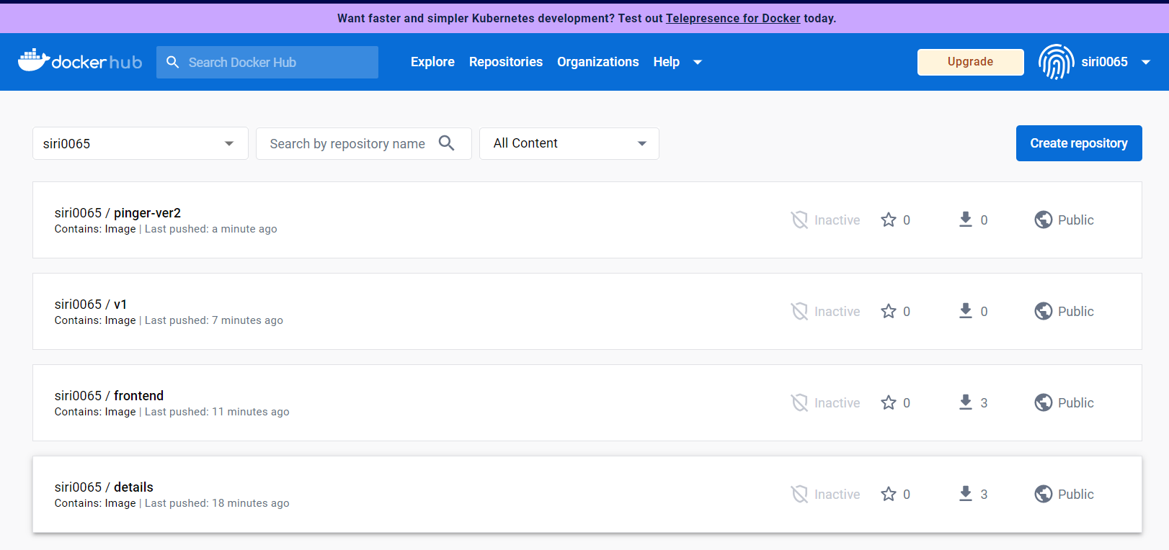

After invoking applications into the container using the docker commands, the applications are stored in the created repositories in “Docker Hub (Public Repository)”.

To maintain the multiple applications in each of the container is bit complicated and wastage of resources, Thus we’re moving to **“Kubernetes”.**

Instead of maintaining multiple applications in multiple containers in the docker, we can invoke the multiple containers which has applications in the single holder called **“Pod”**, it can have minimum 3 applications in the Kubernetes.

We start the Kubernetes using the “Minikube” tool that helps in interacting with the server and create the cluster that contains nodes.

To install the minikube we’ll be using the command: **minikube start**

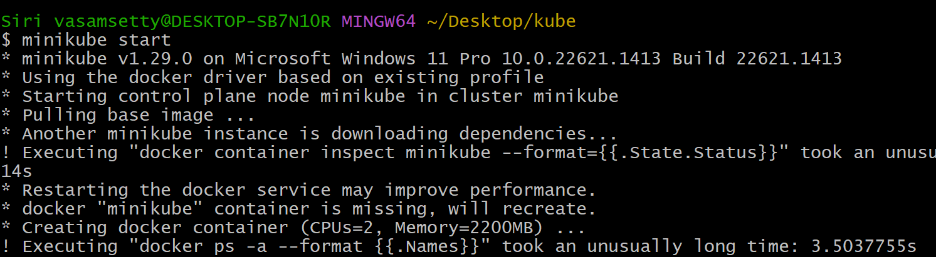

After installing the Minikube, it automatically creates the replica in the docker desktop which is a local repository. Using the kubectl tool we install the Kubernetes.

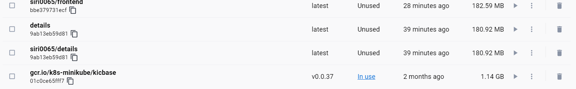

Now we’ll be applying our application (yaml file) to the Kubernetes using the command: **kubectl apply -f detail.yaml** .

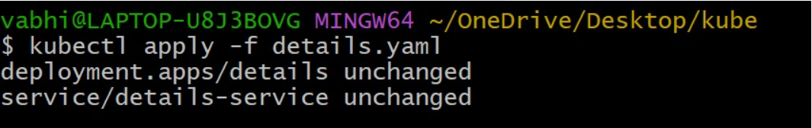

Then we’ll be displaying the nodes created in the Kubernetes using the command:

**kubectl get nodes.**

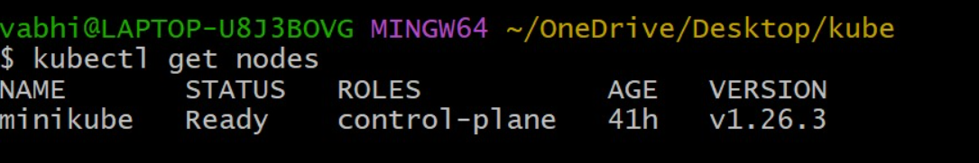

To deploy the application that is loaded into our pod we use the command:

**kubectl get deployment**

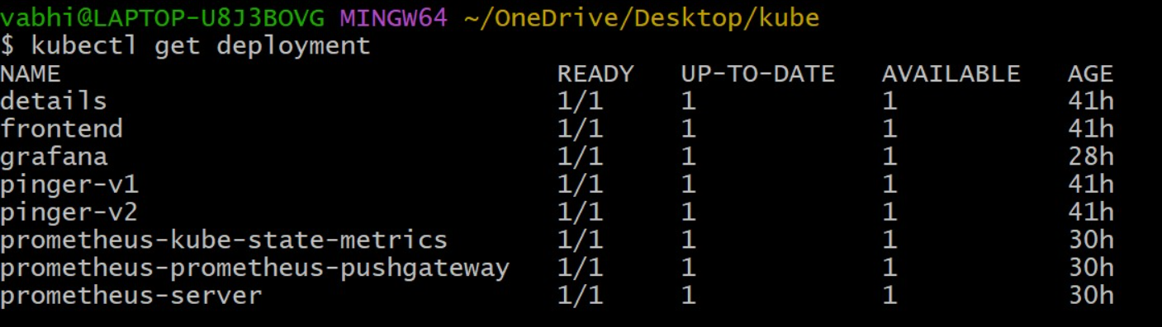

Now we’ll be displaying the service to check whether the application is running accurately or not: **kubectl service details-service**

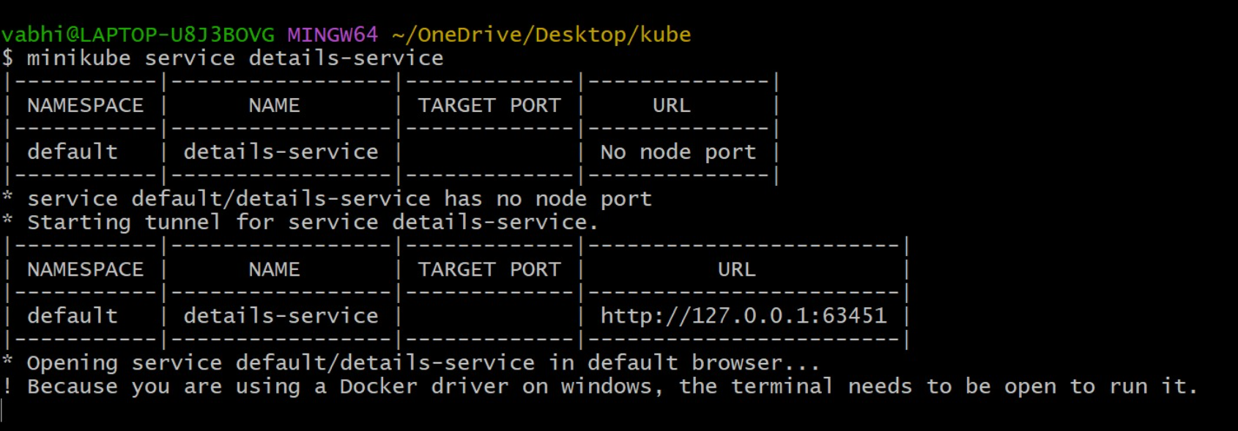

The output is projected as follows:

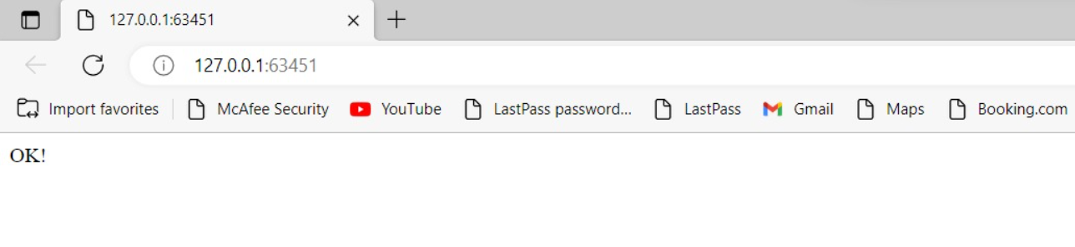

Same ways, we deploy the 4 applications in the Kubernetes using the above the commands i.e., details, frontend, pinger-v1, pinger-v2.

**ORCHESTRATION: MONITORING**

Kubernetes monitoring is a form of reporting that helps with proactive management of clusters. Monitoring a Kubernetes cluster eases management of containerized infrastructure by tracking utilization of cluster resources including memory, CPU, and storage.

**Tools Used:**

**Chocolatey:** Like many DevOps tools, Chocolatey is used to automate repetitive tasks. Specifically, Chocolatey can deploy software packages, applications, zips, binaries, scripts, and installers on Windows machines.

Installation process of chocolatey software:

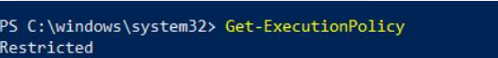

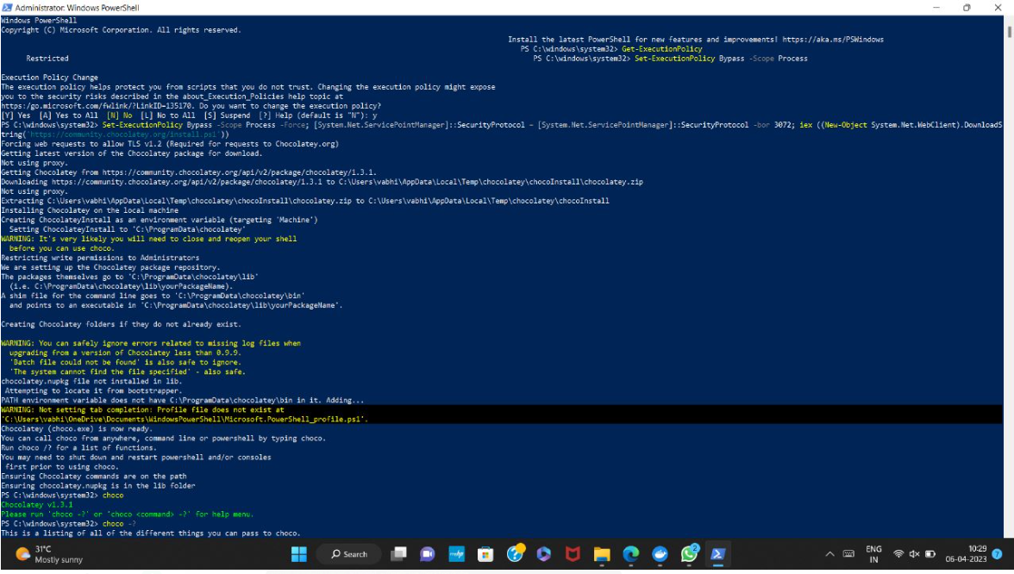

**Helm:** It is a Kubernetes deployment tool for automating creation, packaging, configuration, and deployment of applications and services to Kubernetes clusters.

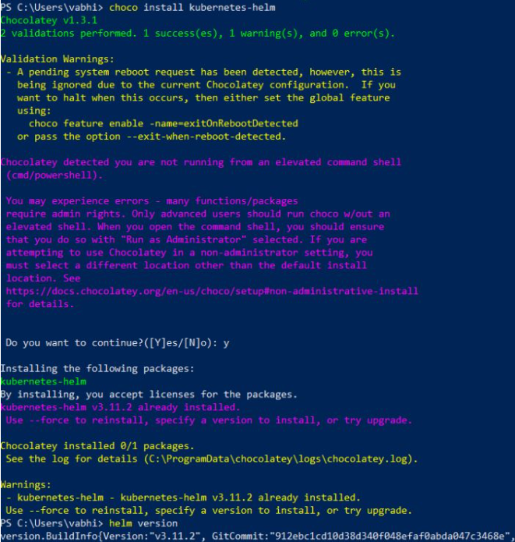

**Prometheus:** It is a free software application used for event monitoring and alerting. It records metrics in a time series database built using an HTTP pull model, with flexible queries and real-time alerting.

Installation of Prometheus:

* **helm repo add prometheus-community** [**https://prometheus-community.github.io/helm-charts**](https://prometheus-community.github.io/helm-charts)

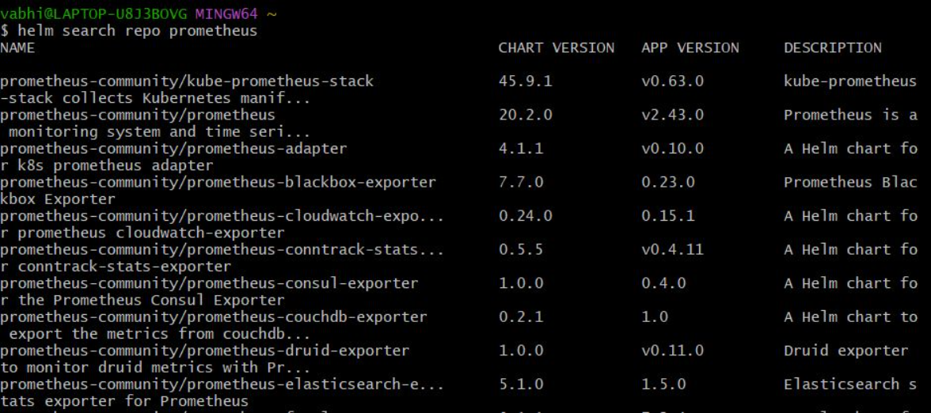

* **help search repo Prometheus**
* **helm repo update**
* **helm install prometheus prometheus-community/Prometheus**
* **kubectl get all**
* **kubectl get svc**
* **kubectl expose service prometheus-server --type=NodePort --target-port=9090 --name=prometheus-server-ext**
* **minikube service prometheus-server-ext**

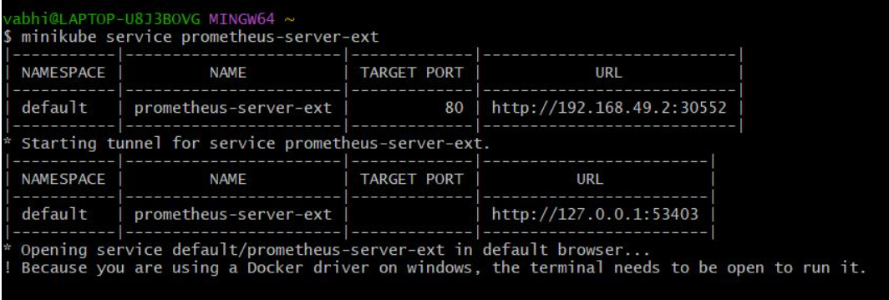

After executing the above command to display the services it redirects to the web browser opening Prometheus which stores the data and acts database.

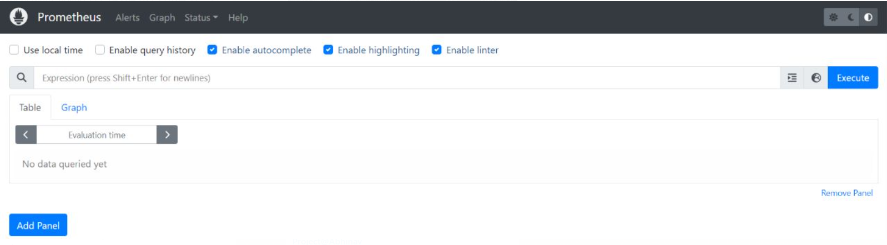

* **kubectl get pods**

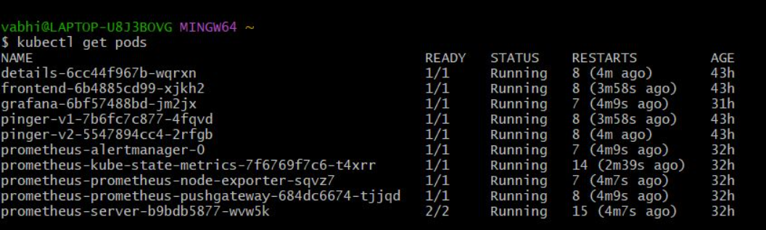

**Grafana:** Itis a multi-platform open-source analytics and interactive visualization web application. It provides charts, graphs, and alerts for the web when connected to supported data sources. Using the Grafana we monitor the applications that we deployed which is represented as statistical metadata.

**helm repo add grafana** [**https://grafana.github.io/helm-charts**](https://grafana.github.io/helm-charts)

**helm repo update**

**helm install grafana stable/grafana or helm install grafana grafana/grafana**

**kubectl expose service grafana --type=NodePort --target-port=3000 --name=grafana-ext**

**minikube service grafana-ext**



After starting the service, it re-directs to the web-application of the Grafana where it displays the statistical meta data.

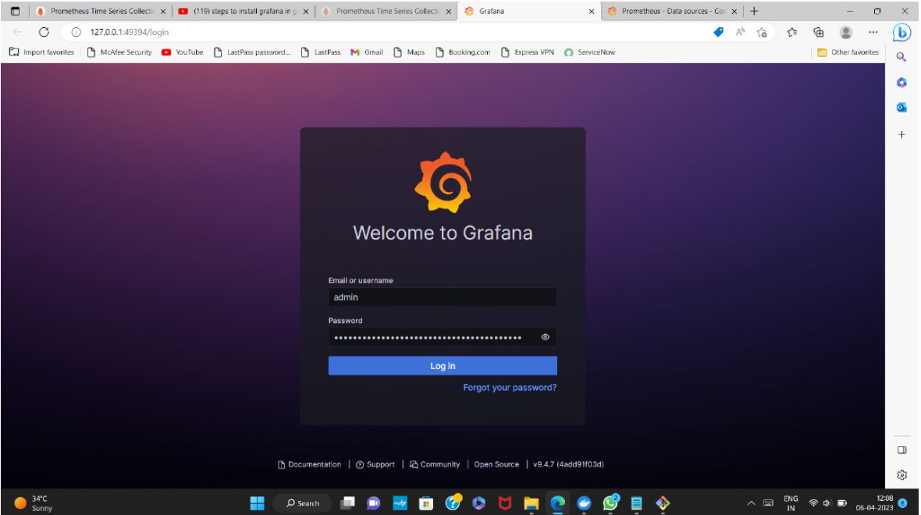

We’ll be navigating to the Grafana page >> then select the “Add your first data source” >>

Now select the “Prometheus” >> select the Prometheus name >> give the default port value “6417” >> assign the url which is displayed when service is created >> select “save & test”.

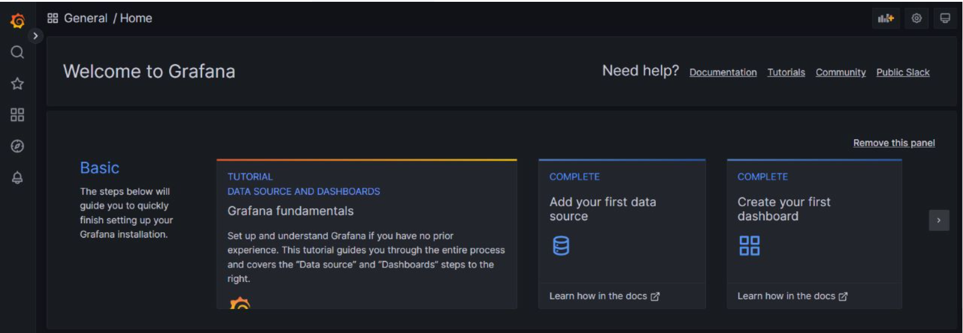

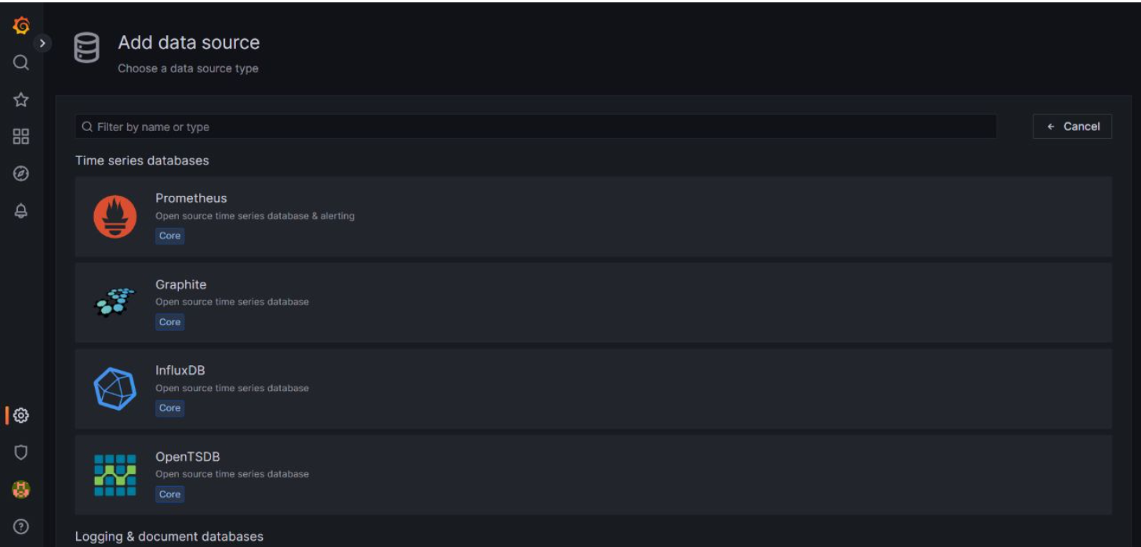

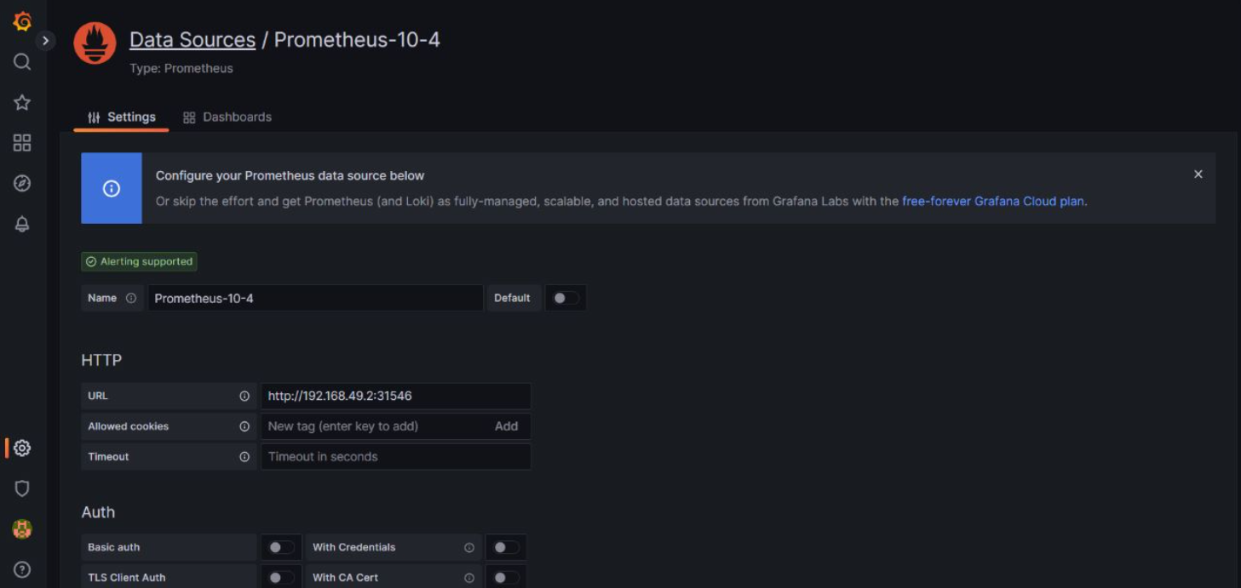

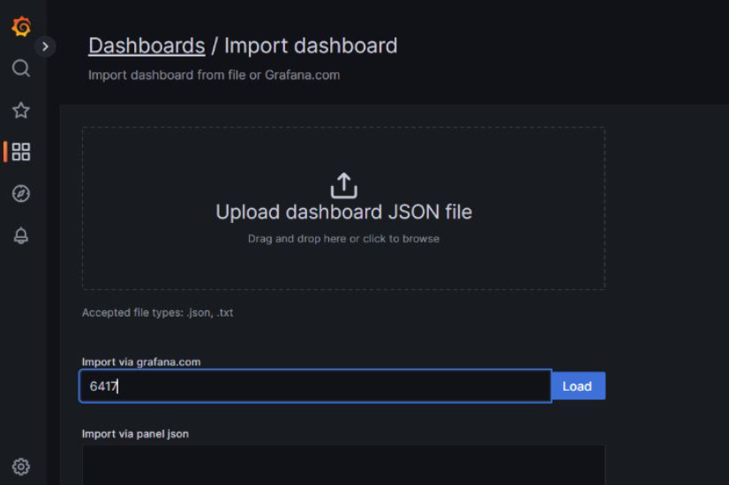

**Outcome:**

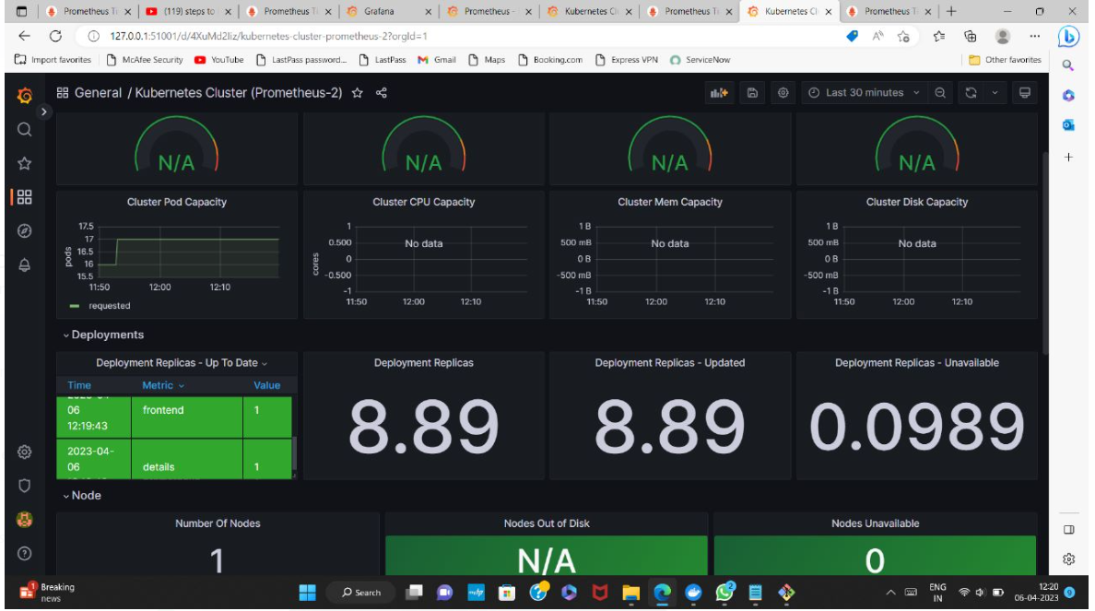

**Real-Time Applications:**

**Pokémon - Go run Gaming Application:**

Pokémon go was developed and published by NIAMITC Inc. The game had more than 500 million downloads and more than 20 million active users.

The developers didn’t expect such an exponential increase in users and surpass the expectations.

They soon realised that the servers cannot handle the amount traffic that they received. Then the application was run Google Kubernetes Engine (GKE), which as the ability to orchestrate their container cluster.

This enabled the team to focus on deploying the live changes for their users.

 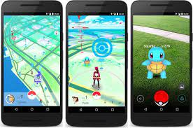

**Conclusion:­**

Kubernetes is a great tool for orchestrating containerised applications. It automates the very complex task of dynamically scaling an application in real time.

Kubernetes orchestration allows you to build application services that span multiple containers, schedule containers across a cluster, scale those containers, and manage their health over time.

Kubernetes eliminates many of the manual processes involved in deploying and scaling containerized applications.

Likewise, understanding how to link Kubernetes up with a wide variety of external systems and practices as varied as an on-premises database and a Continuous Delivery system is critical to efficiently making use of Kubernetes in the real world.